# SL Sentiment & Pricing: Research Summary

*A summary of results from members with student loans surveyed from 12/19 - 12/22/23.*

*Updated: Dec 22, 2023* Contributors: [Robert Schultz](mailto:rschultz@sofi.org) [Alexis McNutt Unis](mailto:amcnuttunis@sofi.org) [Michael Schermann](mailto:mschermann@sofi.org)

**SL actions and plans since repayments have resumed**

1. Since repayments have resumed - 67% of members have paid the required monthly amount or more, 7% higher than the national population[1] - 36% have or plan to enroll in some sort of income repayment plan
2. When looking at refinancing - 13% have already refinanced their loans and 11% still plan to refinance their loans since payments have resumed
3. Among those who have not refinanced, the top 3 reasons include:
   1. 35% state that rates are too high to consider refinancing
   2. 32% are still waiting for some sort of federal loan forgiveness
      1. 42% are confident that federal loan forgiveness will be implemented at some level - of which 15% are *“extremely” or “very confident”*
   3. 27% don’t want to lose federal student loan options/protections

**Acceptable refi-rates to consider refinancing**

1. Using the Van Westendorp pricing methodology[2], optimal interest rate is 3.26% and acceptable interest rate range is 2.85% - 4.04%

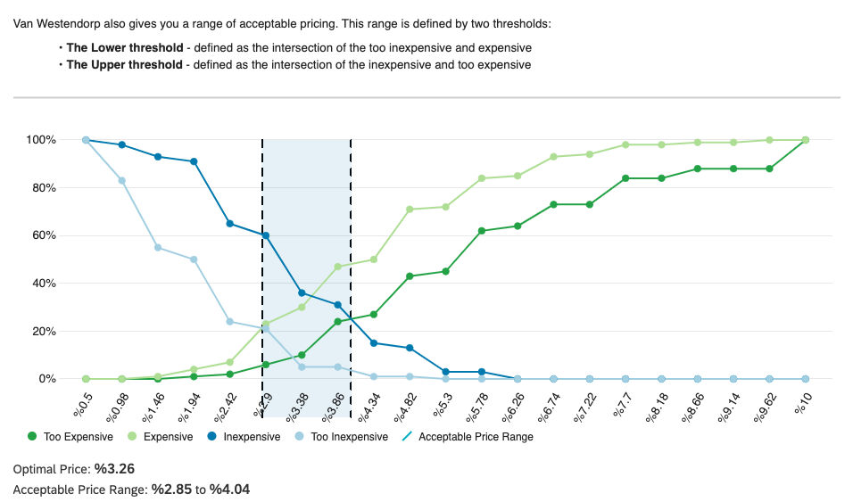

**Member SL composition and sentiment on repayment**

1. 45% of members have student loans, the vast majority of which are federal
   1. 72% have undergraduate federal loans, 28% have graduate federal loans
   2. 37% have private undergraduate or private graduate student loans
   3. 64% of those with student loans report having less than $50k outstanding
2. 1 in 4 members are not sure of the current interest rate for their undergraduate or graduate loans. Among those who know their rate:
   1. 37% of undergraduate loans are at or over 5% interest
   2. 50% of graduate loans are at or over 5% interest
3. 46% of those with student loans are “*extremely” or “very concerned*” about the impact resuming loan payments will have on their current financial situation
   1. 35% have reduced their investment or savings rates and 44% have reduced their discretionary spending

**Acceptable refi-rates for those with SLs at or above 5% interest rate**

* For members with student loans at or above 5% interest rate the **optimal interest rate is 3.43%** and **acceptable interest rate range is 3.08% - 4.40%**

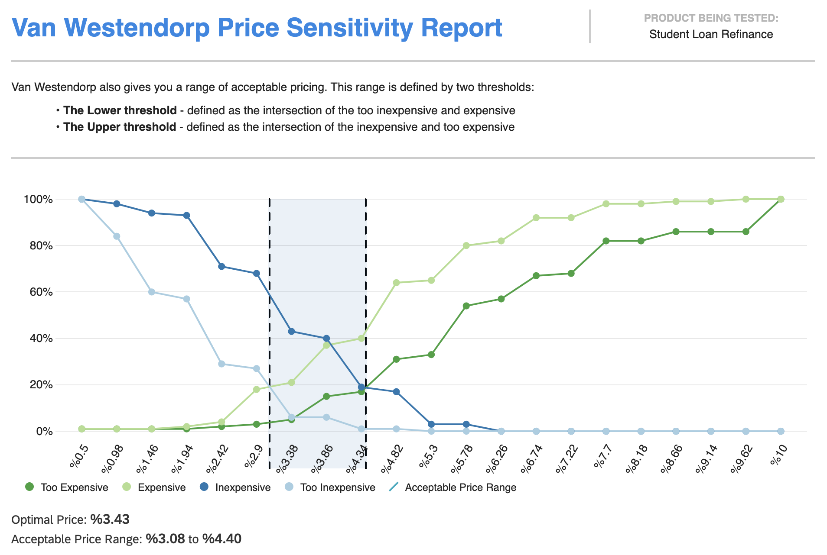

**Methodology**

* A random sample of SoFi members were selected (i.e., excludes registered users)
* A brief survey was fielded through Qualtrics via email the week of December 18th, 2023
* Total of 364 SoFi member completes (n = 364)
* Link to Survey research plan: [23Q4 - SL Sentiment & Pricing Survey - SLR Operating Team Approval](https://docs.google.com/document/d/1--EO1KlIVkbmC5u5z29XZp9LKgtMljIBsw9NmHBd0fs/edit#heading=h.dken21iqaq21)

1. The U.S. Department of Education data showed that 60 percent of the 22 million borrowers with payments due in October made those payments by mid-November: ([Report here](https://blog.ed.gov/2023/12/a-first-look-at-student-loan-repayment-after-the-payment-pause/#more-32203))
2. The Van Westendorp Price Sensitivity Meter is a survey exercise that asks four simple questions to identify how much a customer would pay for a product or service.